

**EXTENSION LECTURE WAS DELIVERED TO GOVT JUNIOR COLLEGE STUDENTS BY SRI V.CHITTIBABU, LECTURER IN COMMERCE, SGA GOVT DEGREE COLLEGE, YEALLAMANCHILI**

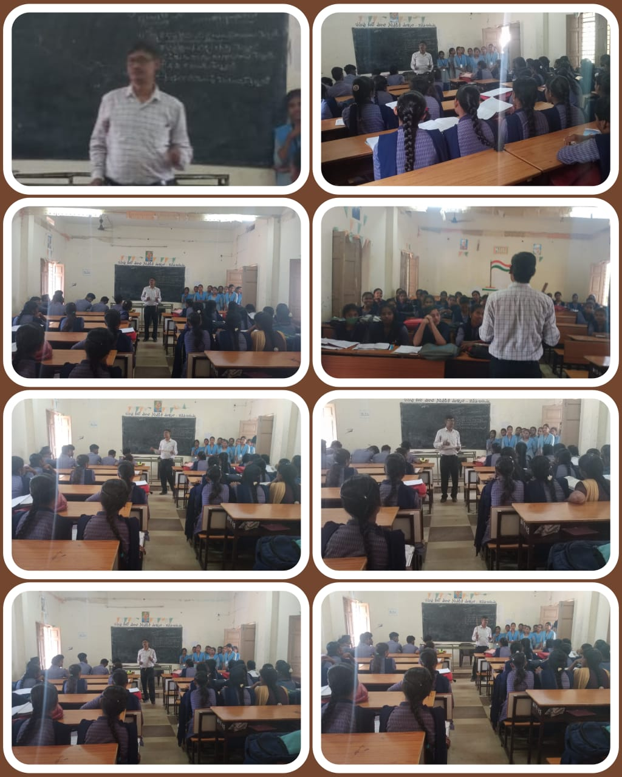



**B.COM 3RD SEM STUDENTS, SGA GOVT DEGREE COLLEGE, YELLAMANCHILI, HAVE COMPLETED THE SYLLABUS OF C.E.C. GROUP IN THE GOVT JUNIOR COLLEG, YELLAMANCHILI** 